A&W 2W Proposal

[Background ]
Low end model:
1. HCI BT chipset always includes BLE + Classic ( HFP , A2DP …SPP). Classic can do phone call,
music playing, but a MFi chip (30cents or so) needed for data transfer(SPP) for iPhone.
2. Map (image) transfer, 30KB(byte)/10 FRS thru BLE heard from Neusoft. Without any overhead (not
possible), limitation of BT chip for BLE is 160KB (if 30KB, only 5 FRS), SPP is around 250KB (30KB,
8 FRS). Perry will check with chip makers if there is any other way to enhance the speed of data
transfer.
3. With SPP, A&W also can do much more functions for BT that might be good for customers. For
MAP (image) transfer, we can try to reduce the overhead for BT and system. That is our
advantages.

M to High end:
1. BT, of course, we have the best solutions.
2. CPAA or CarLink (for China)
3. MAP streaming thru wifi. This is much lower cost than CPAA. We are doing a non-aps in phone
solution. This is a killer function for this application. The end of this May, will have a prototype
from our RD. But, I guess still needs several months (ex., end of this year) to really have it ready.

[ Nippon Seiki Bluetooth RFQ ]

1. Low-end ( BLE function with Map streaming)
1-1 HCI Type advantage
- Lower cost
- Higher Throughput & Performance
- Better flexibility to meet customer spec:
Ex: Support more customer profiles,
Multi-device concurrent usage(smartphone + peripherals )

1-2 A&W BT Solution Advantage
- Higher transfer speed
Ex: Map : Thru BLE( around 5 FRS ) , SPP ( around 8 FRS )
Data Transfer for image / Icon / Firmware upgrade
- Small footprint
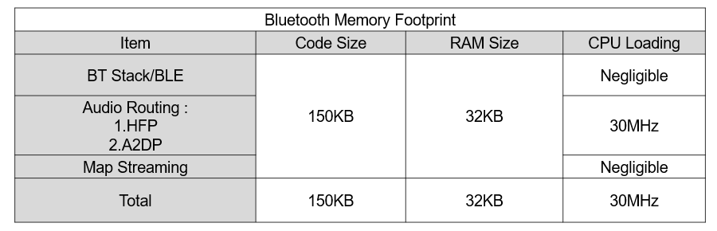
- Provide app template: reduce integration effort
- Best IOP

2. High End : BLE/Classic , CP/AA
2-1 A&W Bluetooth Solution :
Comprehensive Support: Meets all Bluetooth requirements.
Highly Configurable: Tailored to fit diverse product specifications.
- Support Classic , BLE , LE Audio Profiles
- Customer Profiles: for Incoming Call and Message Notifications/ Music Control/ UI control, Screen / Icon / Firmware update…
- BLE Profiles: TPMS, HOGP, Current Time; Apple Notification Center Service(ANCS) (iOS),
Apple Media Service (AMS) (iOS)
- Keyless Access
- MESH for Fleet
- Multi-device concurrent usage ( smartphone + peripherals + helmets)
- Provide iAP2 / OOB / MFi Authentication for CarPlay connection
- Optional: Find My / Find My Device

2-2 A&W Bluetooth Advantage:
- Feasibility check ; Verify chip’s limitation: ex: 2~3 SCOs, PLC, SOC Limitation
Note: If necessary, support POC program(HW+SW)
- Meet customer spec requirements and Extend features
Audio Routing : HFP , A2DP , LE Audio ;
Intercom between driver and passenger
One SOC connects multi Bluetooth chips
- Best IOP : Will be based on A&W specifications and can also use customer's test specifications

2-3 A&W CPAA : Ready for certification
- A&W typically already maintains corresponding in-house EVB (e.g. TCC, MTK...) integration
and validation environments for CP/AA audio solutions, system port ( WiFi / USB ), helping
accelerate customer wired/wireless CP/AA bring-up, platform integration , issue analysis,
and certification preparation

2-4 A&W also has ECNR and Map Thru WiFi ( non-App) solution

[Q&A]
1. BLE Only or Classic + BLE ?
If BLE Only
Smartphone connects meter and helmet?
If Classic + BLE
Which connection type?
Smartphone connects meter and helmet
Meter connects smartphone and helmet

2. Using one Bluetooth Combo Chip
Support Mirroring APP : CP/AA or ?
Streaming ( Image / Map…) Transfer thru WiFi?

3. One SOC connects Multi chips ( one combo chip + one / two BT HCI Chips )
Connection Type : One BT chip for smartphone, the other connect helmet or ?

[Appendix]

1. BLE Max Speed: Around 160KB
藍牙低功耗（Bluetooth LE, BLE）自藍牙 5.0 引入 LE 2M PHY 之後，實體層（Physical Layer）的晶片訊號調變速度達到了 2 Mbps。
然而，因為通訊協定存在封包標頭、校驗碼（CRC）、以及封包與封包之間的強制間隔時間（Inter-Frame Space, $T\_IFS = 150\,\mu\text{s}$），應用層（Application Layer）實際能達到的最高有效資料傳輸速度（Maximum Net Throughput）大約落在 1.3 Mbps 到 1.4 Mbps 之間（理論極限值約為 1.434 Mbps）。

2. SPP Max Speed : Around 250KB
在藍牙 2.0+EDR（Enhanced Data Rate）及之後的版本中，實體層（Physical Layer）的空中最大速率為 3 Mbps。然而，扣除掉藍牙基頻（Baseband）、L2CAP、RFCOMM 的封包標頭（Headers）、校驗碼以及雙向切換的時槽開銷，SPP 在應用層的理論最高單向傳輸速度大約是 2.1 Mbps（實際極限約在 1.3 Mbps ~ 1.8 Mbps 之間，遠高於 BLE 的實際吞吐量）。

3. Smartphone connects meter and helmet
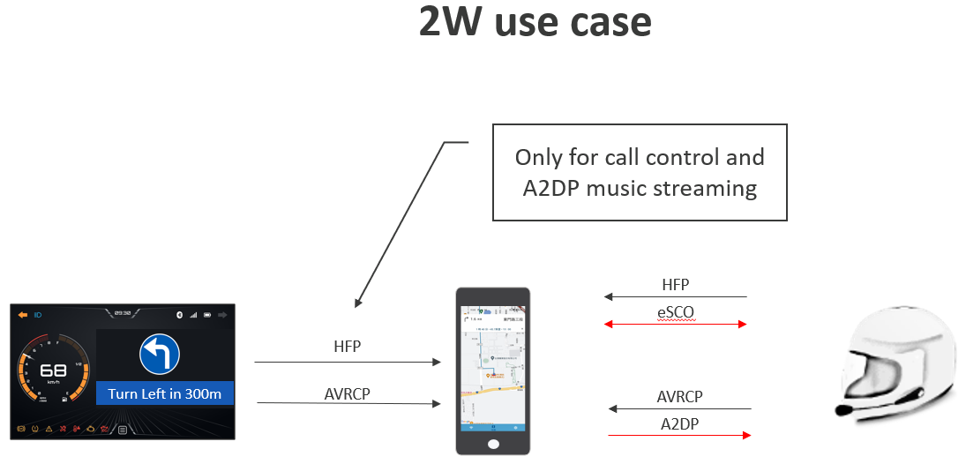

4.
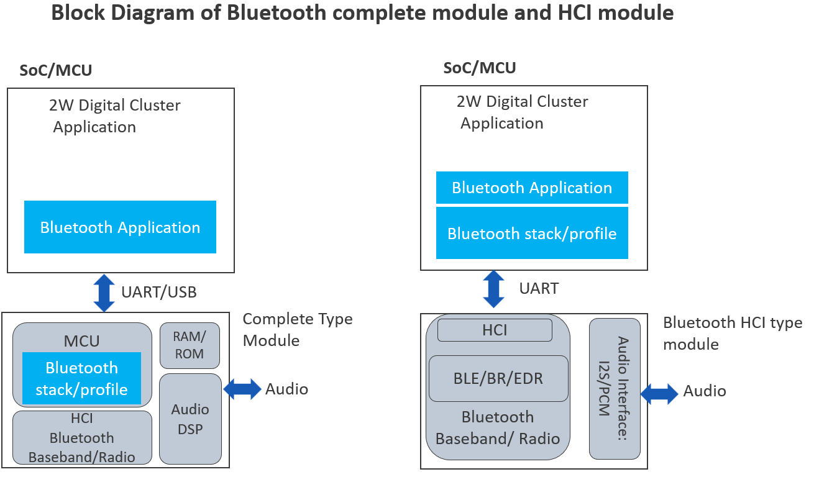

[ 2W Functions]
1. Bluetooth:
Classic:
- Handsfree call on Helmet Headset ( HFP )
- Intercom between driver and passenger ( HFP )
- Music sharing (A2DP, AVRCP)
- Map Streaming transfer thru SPP
- Classic Profiles: PBAP, MAP, HID…
- Provide iAP2 / OOB / Authentication for CarPlay connection

BLE
- Turn by Turn data transfer; Stream Phone’s Map screen to Digital Cluster
- Sync vehicle data (fuel level, mileage, maintenance alerts, and ride logs) and configure cluster display settings.
- Vehicle sensor data transfer
- Customer Profiles: for Incoming Call and Message Notifications/ Music Control/ UI control,
Screen / Icon / Firmware update…
- BLE Profiles: TPMS, HOGP, Current Time; Apple Notification Center Service(ANCS) (iOS),
Apple Media Service (AMS) (iOS)
- Keyless Access
- MESH for Fleet

LE Audio:
- Audio Routing; Phone Call ; Music Sharing

2. Mirroring : CarPlay / Android Auto ( ??? _

3. Map Streaming through Wi-Fi
- Stream Phone’s Map screen to Digital Cluster
- Mobile APP : Frame Rate ???
- Non-App : Frame Rate ???

4. Other :
- Support Voice Triger, Offline VR
- One SoC with two/ three BT Chips
- NR

